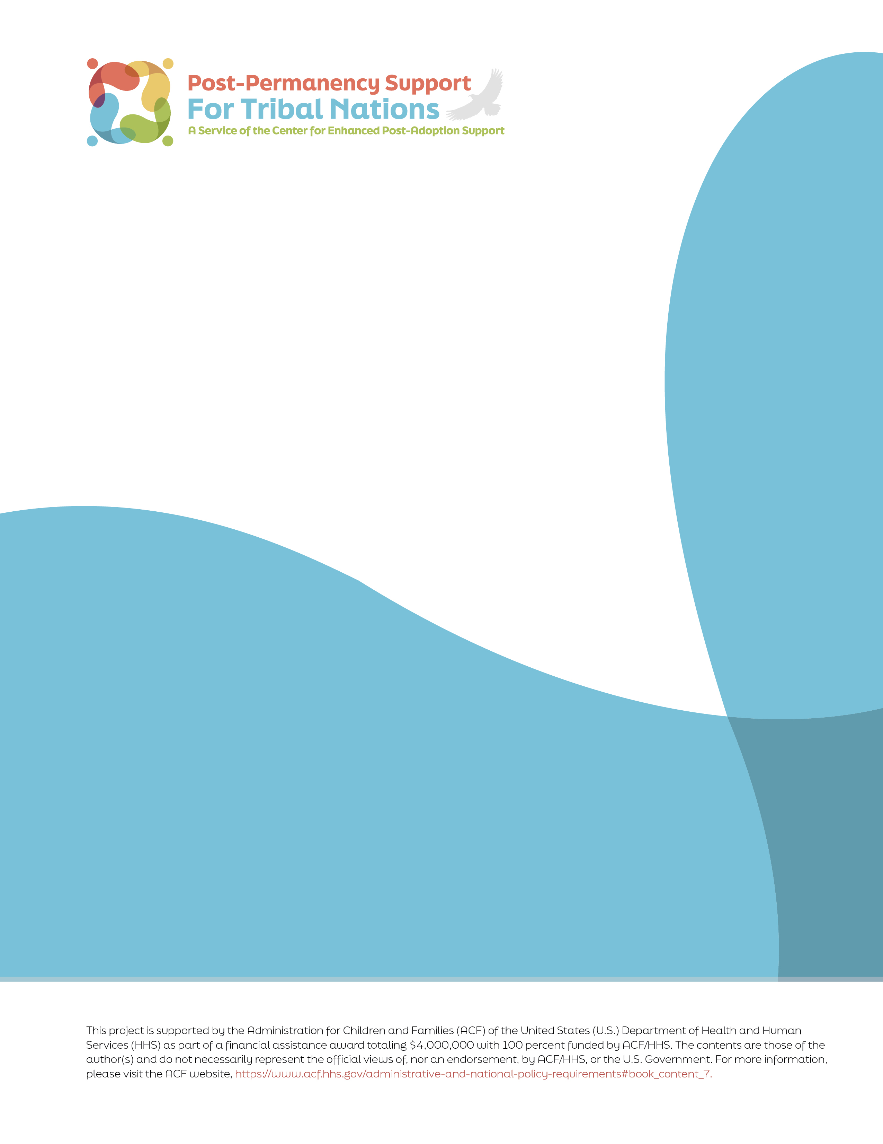

# Developing a Tribal Specific Guide

# for Resource Families Who Contact a Tribal Nation Regarding the Child in their Care

**Raising Our Relatives: A Tribal Guide for Resource Families**

## Introduction

Not all Native children in permanent placements are raised by people from their Tribal Nation. Each year, a disproportionate number of Native children across the nation enter the foster care system. While family reunification is a high priority in every child welfare system, it is not always possible. Sometimes, the families that are raising these children will contact the Tribal Nation seeking information and connection. This Guide has been created as a template for Tribal Nations that want to develop something to share with resource families that provides information and guidance and importantly, offers cultural connections to the child. This type of document can be especially useful when families want to learn how to be respectful and supportive of the child’s Native identity and connection to culture and community but don’t know where to begin.

Throughout this template, the term “resource family” refers to the guardians, adoptive parents, and kinship caregivers who are raising Native youth. Each section of the guide has an explanation of what the section can do and suggests language that the Tribal Nation may want to adapt for their own guide. This document is designed as a template that provides Tribal Nations with an outline and suggested language that can be used to create their own resource guide. Tribal Nations will need to fill out the template with information that is specific to their Tribe. This guide is freely available and Tribes are encouraged to adapt, add to, or remove sections in the template based on what is best fit for each Tribal Nation.

www.postadoptioncenter.org



**Name of Tribal Nation**

Tribal Specific Guide Information for Resource Families Raising our Relatives

Tribal Seal Here

# Contents

Section 1: Welcome & Purpose 4

Section 2: Where to Start – Who to Talk To 4

Section 3: Enrollment Information 5

Section 4: Events and Learning Opportunities 6

Section 5: Cultural Awareness and Consideration 6

Section 6: Community Loss and Grief 7

Section 7: Historical Context 8

Section 8: Staying Connected from a Distance 8

Section 9: Calendar and Resources 9

Closing: A Note on Respect 10



**Section 1:   
Welcome & Purpose**

## Section 1: Welcome & Purpose

Explanation of what this section can do:

In developing a Tribal-specific guide, this section provides an opportunity to offer a culturally grounded welcome to anyone caring for a child who may be from the tribal community. Tribes may wish to include a greeting from Tribal leadership, a child welfare/social services representative, or a cultural advisor. This is the first chance to set the tone, inviting conversation with an open approach that welcomes respectful and appropriate questions from caregivers who are unfamiliar with the child’s Tribe.

In this guide, your Tribal Nation may want to prompt the resource family to consider the purpose for contacting the Tribe about a child they have in care. The Tribe may wish to customize this section by suggesting reliable ways for resource families to confirm information about the child’s possible Native identity before contacting the Tribe. Ways to confirm information might include gathering available records from the social services agency that was involved in the child’s placement, contacting the Bureau of Indian Affairs, as well as the child self-identifying as belonging to the Tribe.

Suggested language*:*

*The purpose of the guide is to help you care for a child who is a member of our Tribe in a way that is respectful, safe, and culturally appropriate. This guide aims to help you honor the child’s heritage and maintain connections to our Tribal Nation, especially if you are not familiar with us.*

*For many reasons, there are not always relatives or Native resource families who can provide a permanent placement for the child. We appreciate your care for our tribal member, and we welcome the opportunity to partner with you in raising healthy youth with a strong Native identity and close connections to their relatives and community.*

*As we begin to learn about each other, please prepare information you may have, such as:*

* *Whether you are currently working with our Tribal Social Services, and who you are working with.*
* *Information you have about the child’s Tribal affiliation*
* *Information about whether the child is affiliated with more than one Tribal Nation and which Tribal Nations those may be.*
* *What you know about this Tribe’s history, values, and current community, and how you know it. What are your sources?*
* *Who else do you know from the Tribal Nation?*

*This information will help us help you learn more about the child’s family.*

**Section 2:   
Where to Start – Who to Talk To**

## Section 2: Where to Start – Who to Talk To

Explanation of what this section can do:

This section can provide details for families as they navigate communicating with the Tribal Nation.

Every tribe has a multitude of services and tribal departments. It can be daunting to learn where to begin and who to contact. When in doubt, resource families may reach out directly to the tribal government offices.

In this section, the Tribal Nation may want to include information about who to contact to get more information to develop connections in the community. This guide suggests as an example that the first point of contact is Tribal Social Services, which then makes referrals to other service providers and has a list of tribal members or organizations who are willing to speak to and educate youth and their families about various issues such as history, culture, and tribal government operations. In this section, you may also want to explain to people how to respectfully request a conversation or learning opportunity, tips on how to interact appropriately, and how to support these activities, and what to do if they make a mistake when interacting with people.

Suggested language*:*

*The Nation has a Tribal Social Services program with staff who can support families that want to maintain connections with the tribal community. Social Services can refer you to the cultural resource program which can suggest books, movies, and webpages that are good sources of knowledge about our history and values and suggest community gatherings to attend. The Cultural Resource Program can educate you about any protocols that you need to know so that attendance is respectful and welcomed. To contact the Tribal Social Services program, please call XXX-XXX-XXXX.*

*Additional information is available through:*

* *Links to the Tribal website, Facebook pages, etc.*
* *Tribal programs, including cultural programs, that resource families may contact*
* *Titles of books and materials that are approved as authentic resources by the Tribe*
* *Events that resource families may attend with the child, including pow wows, educational events, etc.*
* *Any written protocols that Tribal Nations may provide to guide resource families in their interaction with the Tribe*

**Section 3:   
Enrollment Information**

## Section 3: Enrollment Information

Explanation of what this section can do:

Resource families may have questions about the child’s enrollment. The child may be enrolled with the Tribal Nation or may be eligible for enrollment but not yet enrolled. The child might also be descended from multiple Tribal Nations and not enrolled in any of them. In this section, the Tribal Nation can provide clear, specific information about its enrollment process. You may include contact details for the Tribal Enrollment Office or the person responsible for handling enrollment matters. If your Tribal Nation has particular forms, timelines, or documentation requirements, you can list them in this section direct resource families to where those materials can be found, such as a webpage or pamphlets.

Tribal Nations may also want to include a brief explanation of why enrollment matters—beyond access to services, it is a statement of belonging and identity. It’s also helpful to acknowledge common challenges caregivers or agencies may face when working through the enrollment process and to offer supportive language encouraging patience and collaboration. This section can educate readers about how the Tribe handles citizenship and descent.

Suggested language*:*

*The enrollment process for every Tribal Nation is different. Our Tribal Nation enrolls individuals who can establish their eligibility based on the requirements in (cite tribal constitution or code here). To understand these requirements and get copies of the forms that must be submitted, please review the Tribe’s website/request information from…..). To confirm the child’s enrollment status, please (insert the Tribe’s process here). Please understand that the enrollment office has a small staff and the enrollment process is not an automatic or fast process.*

**Section 4:   
Events and Learning Opportunities**

## Section 4: Events and Learning Opportunities

Explanation of what this section can do:

Tribal Nations may want to provide information about opportunities for youth and resource families to learn about and engage in the Nation’s cultural activities such as social gatherings, language classes, and sports events. In addition, the Nation may want to advise the youth and their resource families of the existence of protocols that must be followed prior to attending events and gatherings or visiting sacred places.

Suggested language*:*

*The Tribe and community members host many activities such as language classes, workshops, and community events throughout the year. A calendar of these events can be found (insert place here). Some of these events, such as certain pow wows and community celebrations, are open to the public. Other events are by invitation only. Please contact event organizers for information on how to join the community at appropriate times. The Tribe has a newsletter that is available via email that lists these events. To sign up for the newsletter, please contact (insert contact information here). If you are out of state, we offer online language classes. Information about those classes can be found (insert information)*

**Section 5:   
Cultural Awareness and Consideration**

## Section 5: Cultural Awareness and Consideration

Explanation of what this section can do:

Resource families and youth may not have been given correct information about the Tribal Nation. In this section, the Tribal Nation may want to refer resource families to respected resources, provide information, and address common misconceptions. In addition, the Tribal Nation may also want to educate families about the difference between cultural appropriation and cultural appreciation.

This section can also offer helpful guidance on topics or assumptions that may unintentionally cause discomfort or negative feelings. By learning what to avoid, the resource family can foster stronger relationships built on mutual respect and cultural understanding. Topics you may want to discuss in this section can include:

* Misunderstandings about financial assistance or government programs
* Misuse of traditional symbols, stories, or practices
* Minimizing traditional teachings or ways of healing
* Stereotypes related to family life, education, or substance use

Suggested language*:*

*It is considered respectful to educate yourself about the Tribal Nation, but that can also be confusing because of it can be difficult to know which resources are considered reliable.*

*Youth who have been permanently placed with non-Native families may feel a deep desire to wear clothes, purchase art, and use sayings that they believe reflect the culture of the Tribal Nation. Please contact the Cultural Resources Program at (XXX-XXX-XXXX) to get recommendations about artisans and experts on cultural items and language. Be respectful of the skills these tribal member artisans have developed and the time it takes to create. Listen and watch other members of the Tribal Nation’s community to learn how to be respectful.*

*As you and your child learn about us, it’s important to be mindful about not making assumptions or asking personal questions that may be rooted in common misunderstandings. For example, while some people may believe that all Native individuals receive government payments or special benefits, this is not true.*

*In the same spirit of respect, it’s important not to borrow or imitate cultural expressions such as regalia, songs, ceremonies, or spiritual practices. These are meaningful parts of a living culture, not costumes or decorations, and using them out of context can be hurtful, even if unintentionally so.*

*By being open to learning and listening, you help create a space where Native children and families feel seen, respected, and safe. By honoring these boundaries, you help create a safer and more respectful environment for our Native children and the community that they come from.*

*To learn more about our Nation’s culture, we recommend the following books, videos and articles:*

*List resources*

**Section 6:   
Community Loss and Grief**

## Section 6: Community Loss and Grief

Explanation of what this section can do:

Tribal Nations may want to advise resource families about specific traditions around loss of their child’s loved ones, what they need to know about a child coming back for a funeral and what to expect about traditions (timing), and what will be expected of them as guests in the community if they are invited. There may be protocols around food, dress, and behavior that are expected of guests, including children and non-Native caregivers, to ensure respect is shown to the family and the community. Some Nations hold multi-day gatherings, may restrict photography, or observe periods of quiet reflection or minimal activity. Explaining these expectations in advance can help reduce confusion and promote respectful participation. Some Nations observe specific mourning periods or have practices around not speaking a loved one's name during a particular time. Knowing and honoring these traditions helps the child feel connected and allows caregivers to support their reintegration during emotionally significant times.

Suggested language*:*

*When someone in the community passes away, the entire Nation feels the impact, as Native communities often have deep intergenerational connections and shared responsibilities. For our Tribal Nation (insert language here or contact information for someone who can let the resource family and the child what to expect and about the cultural and community-specific traditions associated with death and mourning).*

*Community loss may also affect communication and participation in scheduled activities. During times of mourning, community events may be postponed or canceled, and tribal staff or extended family members may be less available or temporarily withdrawn from regular routines. It is essential for youth and their caregivers to understand that grief is not only personal but communal, and the loss of even one tribal elder may significantly affect the spirit and rhythm of daily life in the Nation. In these moments, showing respect may involve thoughtfully offering condolences, being flexible with plans, and acknowledging the cultural significance of loss within the community.*

*In our community, it is important to know that (to be filled in by Tribal Nation).*

**Section 7:   
Historical Context**

## Section 7: Historical Context

Explanation of what this section can do:

Understanding the specifics of that tribal history is important for both the resource family and the child. If the Tribal Nation does not have a web page or other materials that people can access to learn more about the specific history of the Nation, this section can include historical information for families caring for the Nation’s children. In this section, you may want to provide an overview of the Tribal Nation’s resilience in the face of their experience with boarding schools and family separation, and removal from and destruction of lands and other resources.

Suggested language*:*

*When you reach out to our Tribal Nation seeking information whether by phone or in person, we want to welcome you with care and context. Understanding our history helps explain why staying connected to our children and families is so important to us. Like many Native Nations, our Tribe experienced significant loss during the boarding school era. For generations, our children were forcibly taken from their families and placed in (name of specific schools or institutions) where they were punished for speaking their language or practicing our culture. Many never came home. These painful events left deep wounds, but they also sparked generations of resilience and determination to protect and care for our children in ways that honor our identity and strength.*

*In our community, it is important to know: (insert additional information here)*

*To learn more about our history and resilience, we suggest the following resources: (insert information here)*

**Section 8:   
Staying Connected from a Distance**

## Section 8: Staying Connected from a Distance

Explanation of what this section can do:

In this section, the Tribal Nation may want to provide tips for staying connected when the family lives far away. The Nation may want to list resources such as newsletters, bulletins, and listservs. In addition, if the Nation has offices in urban areas or is aware of an urban service provider close to where the resource family lives, it may want to provide their contact information in this section.

Suggested language*:*

*Even if you live far from us, there are meaningful ways to maintain connection and support the child’s sense of identity and belonging. You are encouraged to contact (insert information here) to ask about culturally appropriate resources and events the child can engage with from a distance. Signing up for tribal mailing lists, newsletters, and community websites is a great way to stay informed about important news, seasonal celebrations, and educational opportunities. These newsletters offer updates on language revitalization efforts, virtual storytelling events, or cultural activities that children and families can participate in, regardless of their location. Sharing this information with the child can affirm their heritage and show that their culture is a valued and present part of their daily life.*

*Additionally, our (insert name of program) offers virtual classes for youth groups that welcome children living off-reservation or out of state. These opportunities may include language learning, traditional arts, or intergenerational mentoring that helps keep children connected to elders and cultural leaders. If you would like assistance in planning a respectful visit to strengthen relationships and cultural ties, we suggest that you (insert information here)*

**Section 9:   
Calendar and Resources**

## Section 9: Calendar and Resources

Explanation of what this section can do:

If the Tribal Nation has not published their calendar of events on a web page or newsletter, this section can be a place for families to get that information.

Suggested language*:*

*This section offers a comprehensive calendar of events and programs designed for children, youth, and families within the community. The calendar includes local and regional powwows, youth activities, seasonal gatherings, summer camps, and other cultural or educational events. These opportunities help build community connections and provide spaces for cultural expression, learning, and social engagement. Also included are schedules for cultural and language classes that support the revitalization and transmission of traditional knowledge and Native languages. These classes may be offered through Tribal departments, community partners, or local educational institutions.*

*Additionally, this section provides contact information for key program staff who can answer questions or offer guidance on services, events, or enrollment. To support ongoing learning, the section provides suggested books, films, websites, and other resources that reflect Native perspectives and histories. If the Tribal Nation/community maintains a museum, interpretive center, or cultural facility, details such as location, hours, and program offerings will also be provided. The goal is to make it easy for caregivers, youth, and extended family to access cultural enrichment opportunities and build stronger ties to the community and heritage.*

**Closing: A Note on Respect**

## Closing: A Note on Respect

Explanation of what this section can do:

This section can be a place to share information not already addressed in the guide. This can include advice about how not all things about the Tribal Nation are meant to be shared, the idea that building relationships with people in the Tribal community can take time (and that is ok) and language about how culture is not a checklist; it’s lived, protected, and deeply meaningful. This section can close out the resource by reminding the family of the need to be respectful and the importance of being willing to learn and understand.

Suggested language:

*This guide has been developed by the _____ Tribe to support our children when they may grow up outside of our tribal community. Developing and maintaining relationships takes time and thoughtfulness. We are glad that you have taken the first steps and want to support you.*

*In closing the Tribal Nation encourages you to move forward respectfully as you encourage relationships between the Native child, the Nation, and the membership.*

# Appendix

Additional information Tribal Nations may wish to include in their own tribal resource guide can include topics such as:

* Per capita or minor trust fund income, if available
* How to access health services through tribal or Indian Health Services
* Where to learn more information about educational benefits for higher education
* How to obtain tribal identification cards
* Details about tribal programs, services and governance
* Access to any other tribal programs